PPO with Human Coaching Rewards on LunarLanderContinuous-v3
William Armentrout
UTK ID: warmentr

Introduction
Reinforcement Learning (RL) agents traditionally learn exclusively from environment defined reward functions. While effective in controlled simulation environments, this approach often fails to captire the subtle, intermediate behaviors that humans naturally value with teaching or coaching a learner. In robotics, autonomous navigation, and human aligned AI systems, humans frequently provide intuitive guidance such as “stay centered,” “steady your posture,” or “use less force,” which can accelerate early learning or promote more stable behaviors.

The goal of this project is to investigate whether hand-designed human-style coaching rewards, simple heuristic reward additions that mimic human feedback, can meaningfully affect the training dynamics or performance of a PPO agent in the LunarLanderContinuous-v3 environment. Two PPO agents were trained: a baseline model using only the environment reward and a coaching model that receives extra bonuses for behaviors humans typically encourage, such as maintaining upright orientation and staying centered above the landing zone.

Surprisingly, although the coaching PPO demonstrated worse and more unstable learning curves, its final trained policy achieved higher mean returns and lower variance during evaluation. These results highlight that reward shaping fundamentally alters the optimization landscape, and even seemingly helpful human style rewards may initially hinder learning before guiding the agent toward more structured behavior. This report presents the motivation, methodology, experiments, and results, and potential future extensions for the project.

Related Work
This study draws inspiration from 3 major areas of prior work.

1. Reward shaping in RL
Reward shaping has long been used to guide RL agents toward desirable intermediate behaviors. However, prior work shows that shaping can unintentionally bias exploration or destabilize training if not carefully aligned with environment reward (Ng et al., 1999). The current project provides an empirical example of these trade-offs: intuitive coaching signals that increased training instability, but improved final policy quality.

2. Proximal Policy Optimization (PPO)
PPO (Schulman et al., 2017) is one of the most widely applied reinforcement learning algorithms due to its sample efficiency and training stability. Many studies apply PPO to continuous control environments, including LunarLanderContinuous-V3, often finding that PPO converges reliably when trained on the default reward structure. The baseline agent in this project aligns with these findings, showing smooth improvement over training.

3. Human Feedback and Preference Based RL
Recent RL research has explored integrating human preferences or demonstrations into the training process. Human-In-The-Loop RL, RLHF (Reinforcement Learning from Human Feedback), and reward modeling attempt to incorporate human instructional signals to guide policy behavior. This project adopts a simplified version of that idea: instead of human-provided labels, handcrafted heuristic rewards that act as “coaching signals.”
Compared to prior studies, this project differs in that the coaching rewards are intentionally minimal, lightweight, and non-optimal, representing the kind of basic feedback a human might give rather than a fully engineered shaping model. This allows examination of how even small deviations from the environment's built-in rewards influence PPO’s training dynamics.

RL Environment
The experiments were conducted in the LunarLanderContinuous-v3 environment from Gymnasium, a simulated physics-based control task requiring the agent to land a lunar module using two continuous thrusters (Fatama Foundation, n.d.). The environment provides an eight-dimensional observation containing position, velocity, angle, angular velocity, and two leg contact indicators. The goal is to land softly and upright in the designated landing zone at the center of the map.

The environmental reward encourages behaviors aligned with descent control and stability. Positive rewards are given for approaching the landing pad, reducing velocity, and maintaining an appropriate landing orientation. Penalties are applied for excessive fuel consumption, drifting too far from the landing zone, or crashing. The environment was used in its unmodified form for the baseline PPO agent.

For the coaching PPO model, a custom Gymnasium wrapper was implemented to add human-style feedback rewards on top of the environment reward. This wrapper introduced three additional components: a centering bonus that increases as the lander moves closer to the horizontal center; an upright bonus that rewards small absolute angles; and a small penalty applied when thrusters are fired excessively or continuously. These shaping signals were intentionally mild so as not to overpower or replace the environmental reward. The intent was to mimic simple, intuitive guidance that a human might verbalize while observing the agent’s early training behavior.

Methodology
Both the baseline and coaching agents used the same underlying reinforcement learning algorithm: Proximal Policy Optimization. PPO updates the policy using a clipped objective function designed to prevent destructive policy shifts, which is particularly important in environments where unstable updates can easily lead to catastrophic failures.

Each agent used a neural network architecture common in PPO implementations. The actor and critic networks both consisted of two fully connected hidden layers with 64 units each, using ReLU activations. The actor network outputs the mean and log standard deviation of a Gaussian distribution over the two continuous action dimensions, while the critic outputs an estimate of the value function. Both models were trained using the Adam optimizer and identical hyperparameters, including a discount factor of 0.99, a generalized advantage estimation (GAE) parameter of 0.95, and 300,000 total timesteps.

The only methodological difference between the two agents lies in the reward functions. The baseline agent received only the environmental reward, while the coaching agent received the additional shaping signals described earlier. The magnitude of each shaping reward was deliberately small to avoid overwhelming the environment reward, but their structural influence on the optimization landscape was still significant.

During training, episodic returns were logged periodically to produce a learning curve for each agent. After training, each policy was frozen and evaluated in 10 independent episodes to measure performance and stability without further learning. Since these evaluation episodes were conducted entirely without exploration noise, they allow a clearer assessment of policy and quality than training averages alone.

Experiments and Results

Training Performance
During training, the baseline PPO agent demonstrated a relatively smooth and upward trajectory in its episodic returns. It gradually improved from negative rewards into the 150-200 returns range, which aligns with previously reported PPO performance on this environment. Although some volatility remained, especially early on in training, the agent exhibited clear learning progress.

In contrast, the coaching PPO model struggled throughout most of the training period. Its learning curve began with significantly lower returns and showed pronounced fluctuations, including multiple episodes with sharp negative rewards. Interestingly, even near the end of training, the coaching agent’s learning curve remained substantially below the baseline. This indicates that the shaping rewards, rather than smoothing or guiding exploration, may have introduced competing optimization pressures that complicated PPO’s ability to learn effectively under the combined reward signal.

Figure 1. Training learning curves for baseline PPO and Coaching PPO
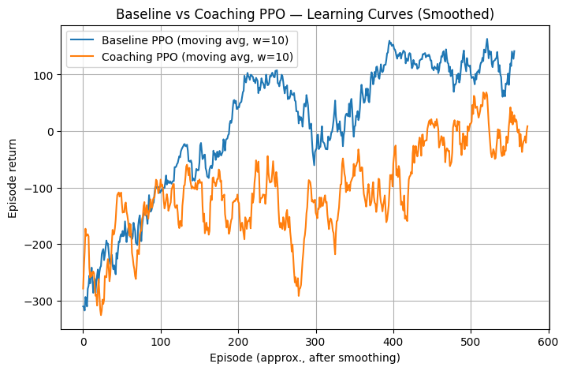
Caption: Comparison of episodic returns during training for the baseline PPO and the coaching PPO. The baseline agent demonstrates smoother improvement, while the coaching agent experiences severe volatility and lower overall returns.

This behavior suggests that reward shaping does not necessarily make training easier; on the contrary, adding human style feedback can complicate gradient estimation, distort advantage values, and frustrate policy improvement if the shaping rewards conflict, even partially, with the environment reward.

Final Policy Evaluation
Despite the inferior training performance, the final evaluation results tell a strikingly different story. When each trained policy was executed for 10 episodes, the coaching PPO agent achieved a higher average return and significantly lower variance compared to the baseline model. The baseline PPO achieved a mean return of 192.81 with a relatively large standard deviation of 90.52, indicating inconsistent behavior across episodes. In some episodes, the baseline landed successfully, while in others it crashed or became unstable.

The coaching PPO achieved a mean return of 225.75 with a much lower standard deviation of 39.37. This indicates that although its training phase was much more chaotic and volatile, the policy it ultimately learned produced smoother, more consistent landings. Qualitatively, the coaching agent’s trajectories appeared more deliberate and centered, with fewer oscillations and more controlled thruster firing patterns.

Table 1. Comparison of evaluation returns for baseline and coaching PPO
 | Mean Return | Standard Deviation
Baseline PPO | 192.81 | 90.52
Coaching PPO | 225.75 | 39.37
Caption: Mean and standard deviation of episodic returns over 10 evaluation episodes for both agents.

These results suggest that human-style shaping rewards may help the agent converge toward a policy with behaviors that are more stable and repeatable, even if the shaping initially makes learning more difficult. The improved consistency suggests that the coaching model internalized patterns of movement that align well with stable landing procedures.

Conclusion and Future Work
This project explored whether human-inspired coaching rewards could influence the learning dynamics and performance of a PPO agent in LunarLanderContinuous-v3. The results demonstrate that even small shaping signals can dramatically affect training. Far from simplifying the problem, the coaching rewards made PPO’s optimization landscape more complex, resulting in lower training returns and significant volatility. However, the final trained policy learned under these conditions was substantially more stable and achieved higher average rewards during evaluation.

These findings illustrate an important insight for reinforcement learning: reward shaping is not merely an additive correction to the environment reward. Instead, it transforms the trajectory space the agent explores and may steer learning toward qualitatively different strategies. Even if shaping rewards hinders early progress, they may ultimately promote more stable long-term behavior by discouraging erratic exploration patterns.

Future work could explore adaptive coaching signals that diminish over time as the agent becomes more capable, allowing early guidance without permanently distorting optimization. Additionally, further experiments across multiple random seeds, larger evaluation sets, and more complex environments would help verify the generality of these findings. More sophisticated human feedback modes, such as learned preference models or ranking-based human evaluations, could also be tested to see whether richer forms of coaching lead to greater improvements in RL performance.

References
Armentrout, W. (2025). PPO with human-style coaching rewards on LunarLanderContinuous-v3 [GitHub repository]. GitHub. https://github.com/WillDBM/ppo-coaching-lunarlander
Farama Foundation. (n.d.). LunarLander — Gymnasium documentation. https://gymnasium.farama.org/environments/box2d/lunar_lander/
Ng, A. Y., Harada, D., & Russell, S. (1999). Policy invariance under reward transformations: Theory and application to reward shaping. In A. McCallum & S. Singh (Eds.), Proceedings of the Sixteenth International Conference on Machine Learning (pp. 278–287). Morgan Kaufmann. https://ai.stanford.edu/~ang/papers/shaping-icml99.pdf
Schulman, J., Wolski, F., Dhariwal, P., Radford, A., & Klimov, O. (2017). Proximal policy optimization algorithms (arXiv:1707.06347). arXiv. https://arxiv.org/abs/1707.06347

